Creating An Auto Mode VPC Network

A VPC network functions similar to a physical network, but it is virtualized within Google Cloud. A VPC network is a global resource consisting of regional virtual subnetworks(subnets) in datacenters connected by a global wide area network. In Google Cloud, VPC networks are logically separated from one another.

VPC offers following benefits:

* Provides connectivity for your Compute Engine virtual machine (VM) instances, including Google Kubernetes Engine (GKE) clusters, App Engine flexible environment instances, and other Google Cloud products built on Compute Engine VMs.
* Offers native Internal TCP/UDP Load Balancing and proxy systems for Internal HTTP(S) Load Balancing.
* Connects to on-premises networks using Cloud VPN tunnels and Cloud Interconnect attachments.
* Distributes traffic from Google Cloud external load balancers to backends.

1. Once you first log in, your screen should look similar to this.

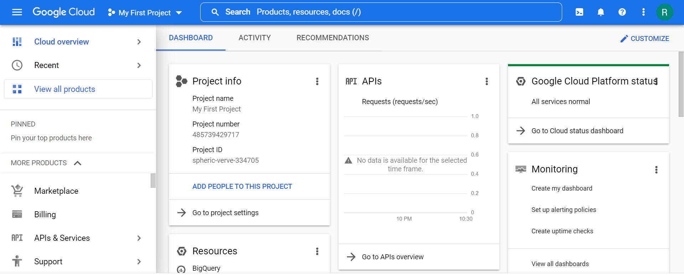

1. Click on the project selector drop-down menu at the top of the screen.

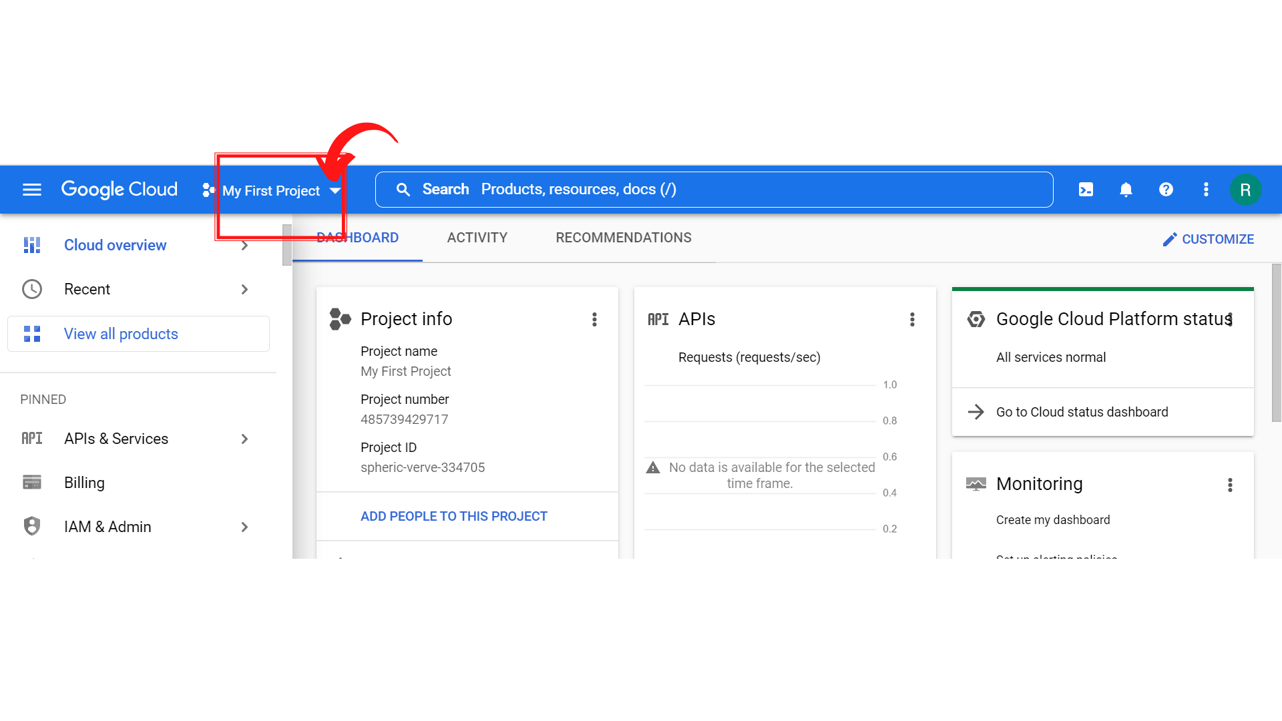

1. Since, we are doing labs on a Security Labs project, Click on *“Security Labs”*.

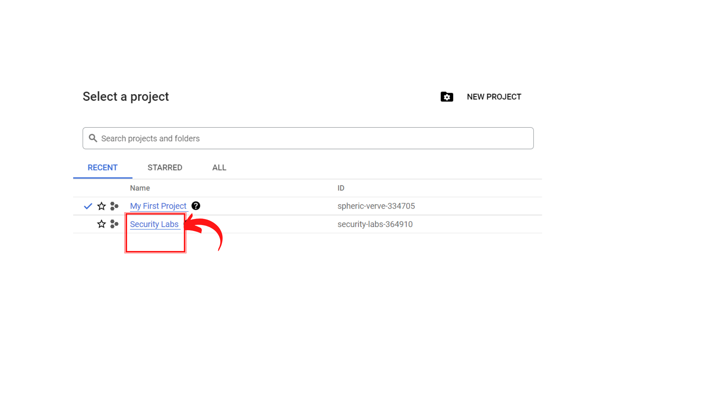

1. Your screen should look similar to this with project info changed to “*Security Labs”* project.

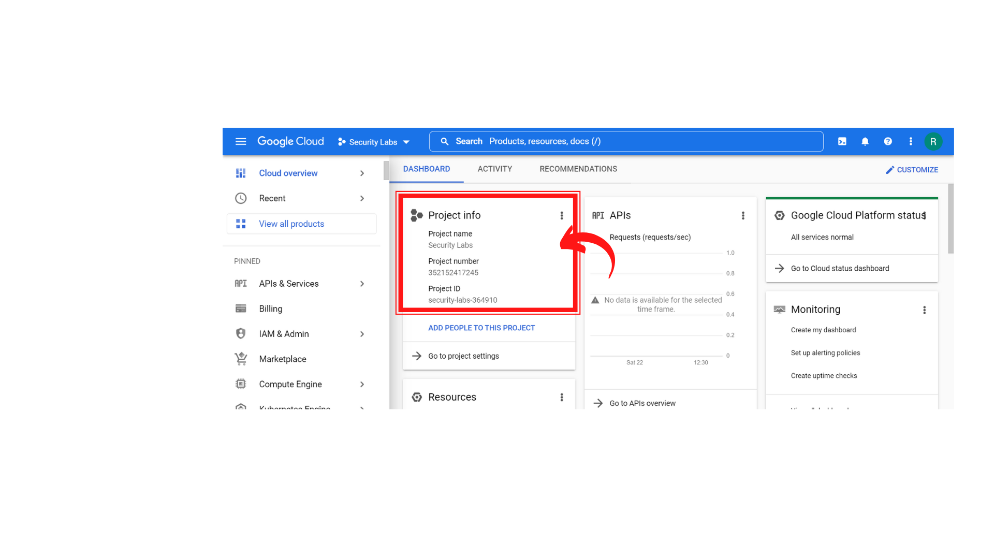

1. To create a new VPC Network, Click on *“Navigation menu”* on top left, then click on ***“VPC Network → VPC Networks”***

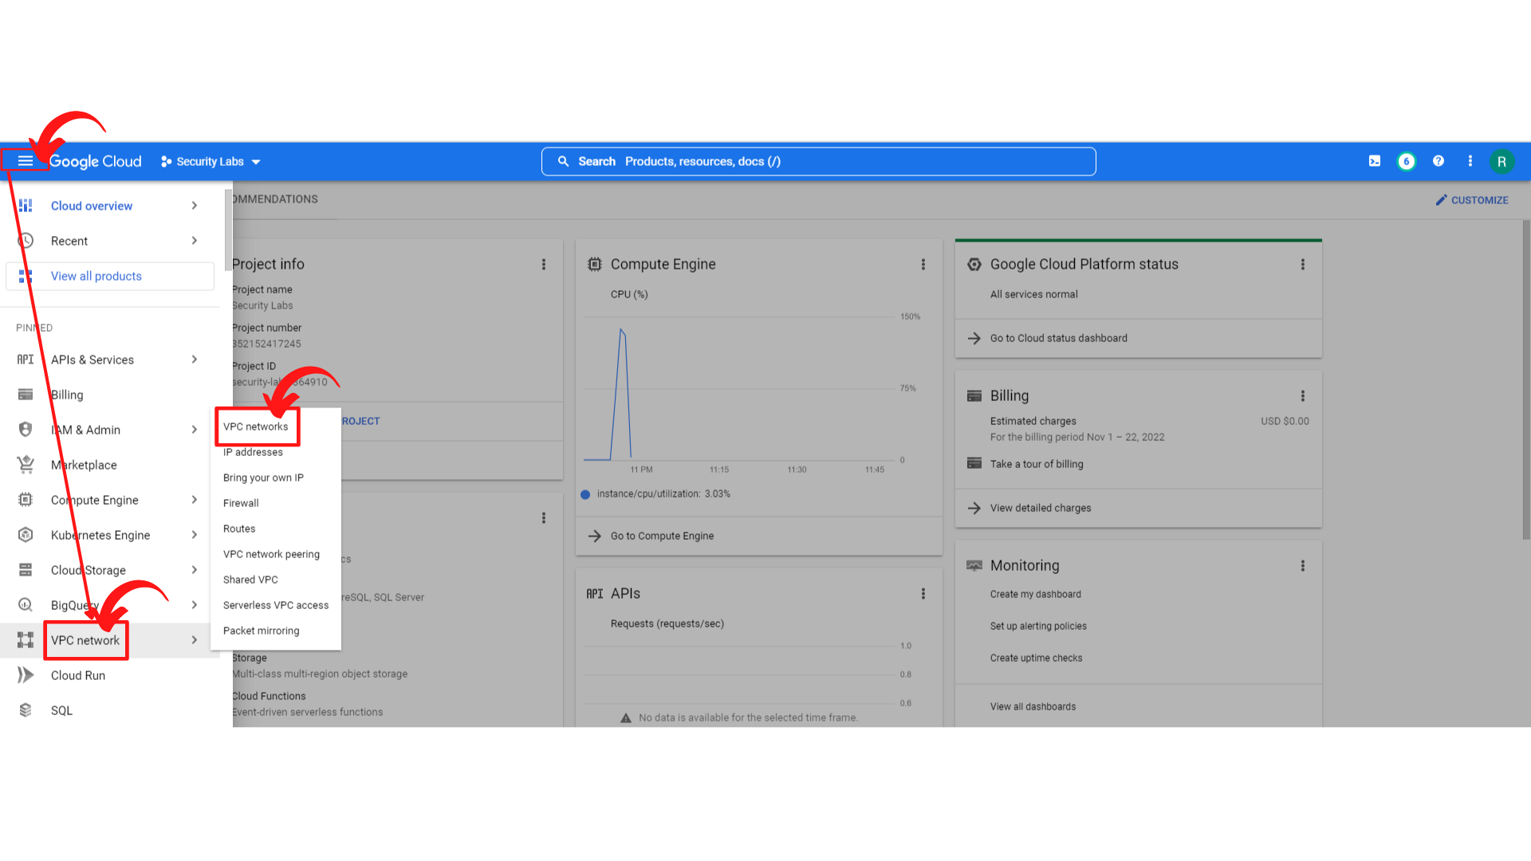

1. Your screen should look similar to this and *“Click → Create VPC Network”*

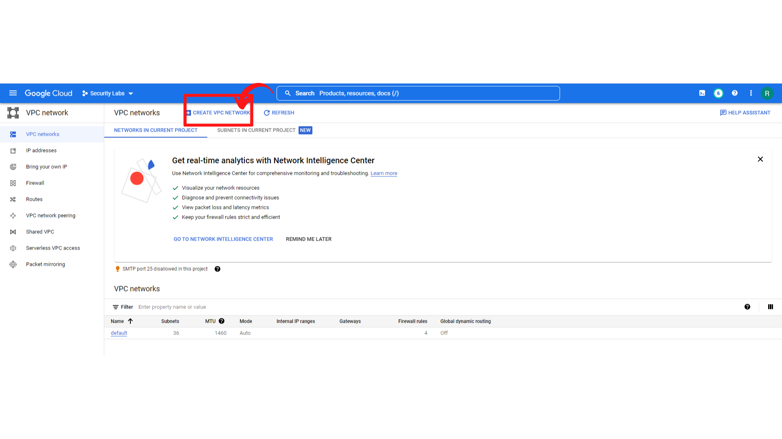

1. Your screen should look like this and ***Enter the Name*** and ***Description*** of the VPC network.

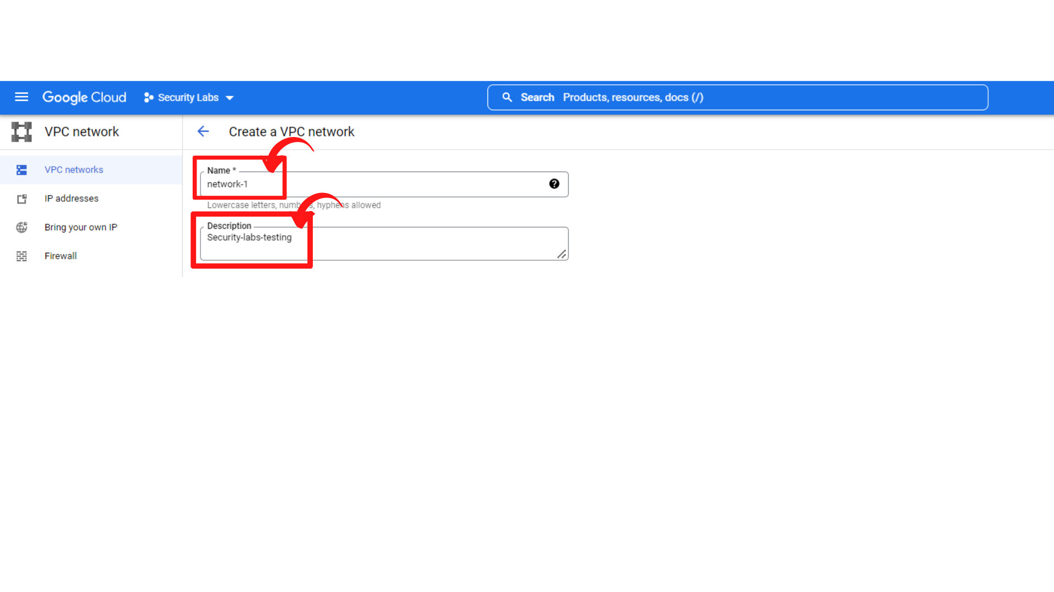

1. Now scroll down, since we creating auto mode VPC Network and select ***“Subnet creation mode → Automatic”***

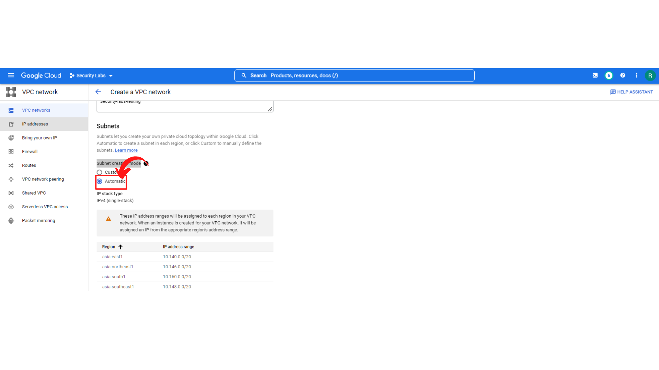

1. Now scroll down to see firewall rules section, In the ***Firewall rules section***, select zero or more predefined firewall rules. Here I'm not adding any Firewall rules.

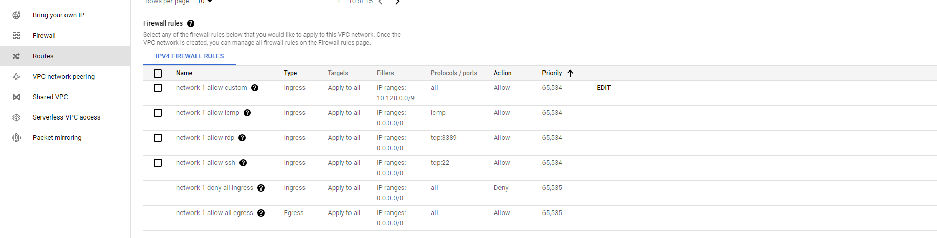

1. Now scroll down to see ***Dynamic routing mode and Maximum transmission unit (MTU)***, select the Dynamic routing mode for the VPC network and **set default MTU as 1460** and ***“Click → Create”***

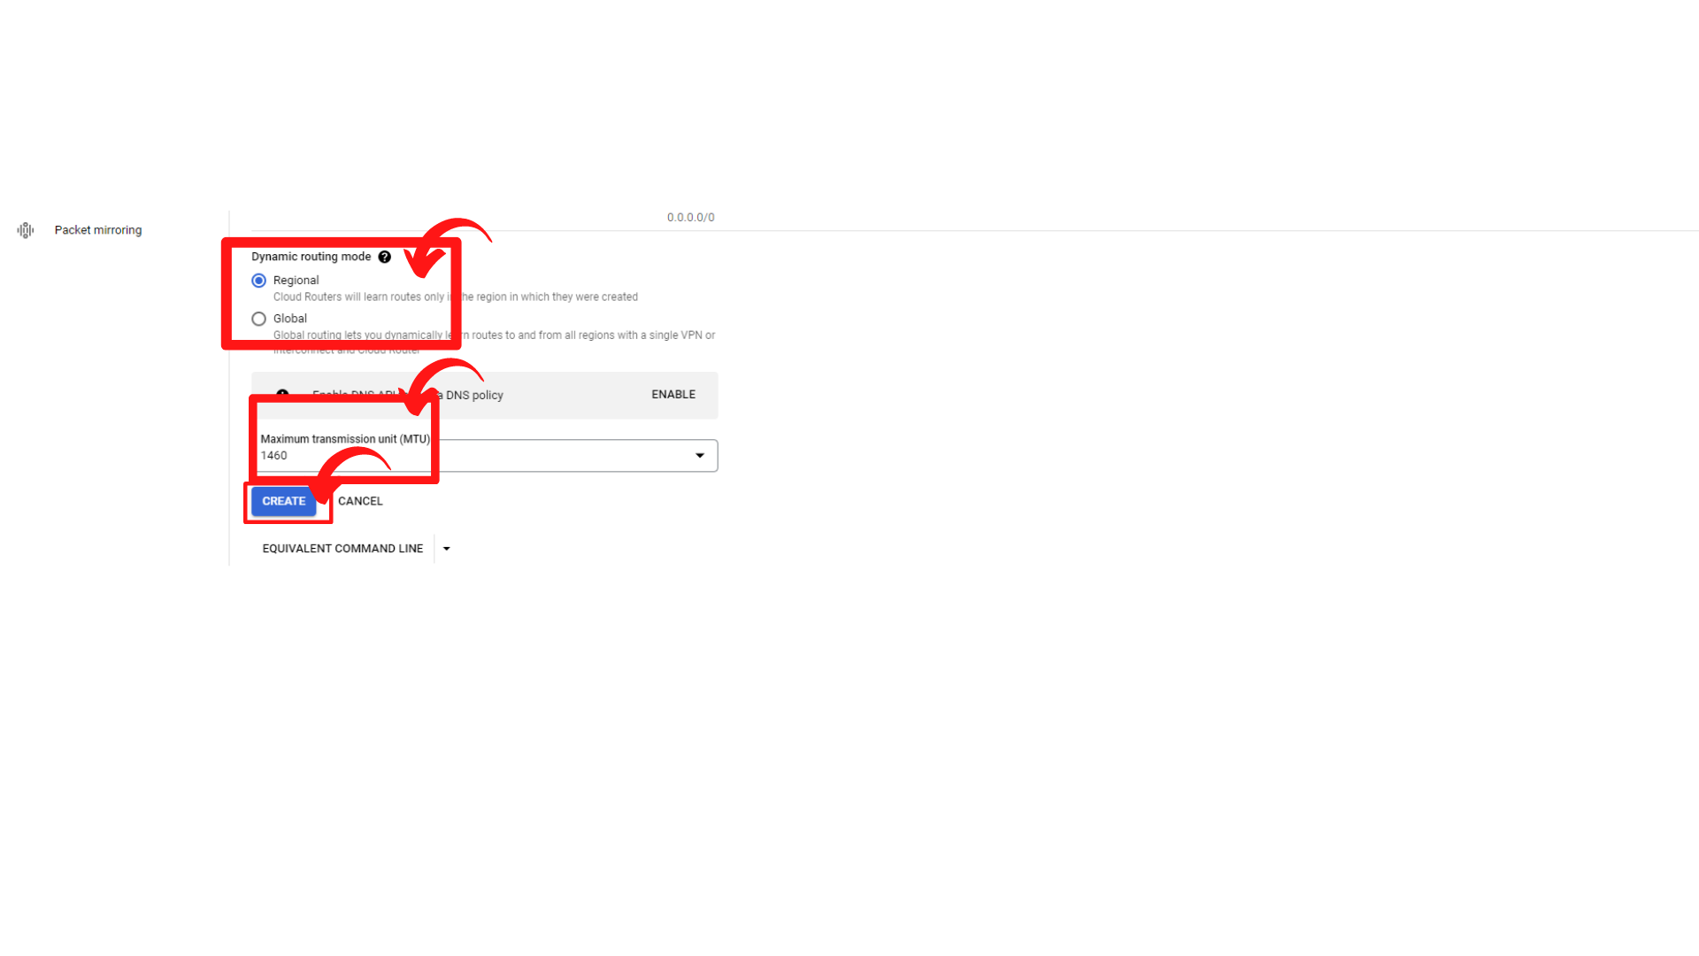

1. Your screen should look similar to this with the new VPC Network added.

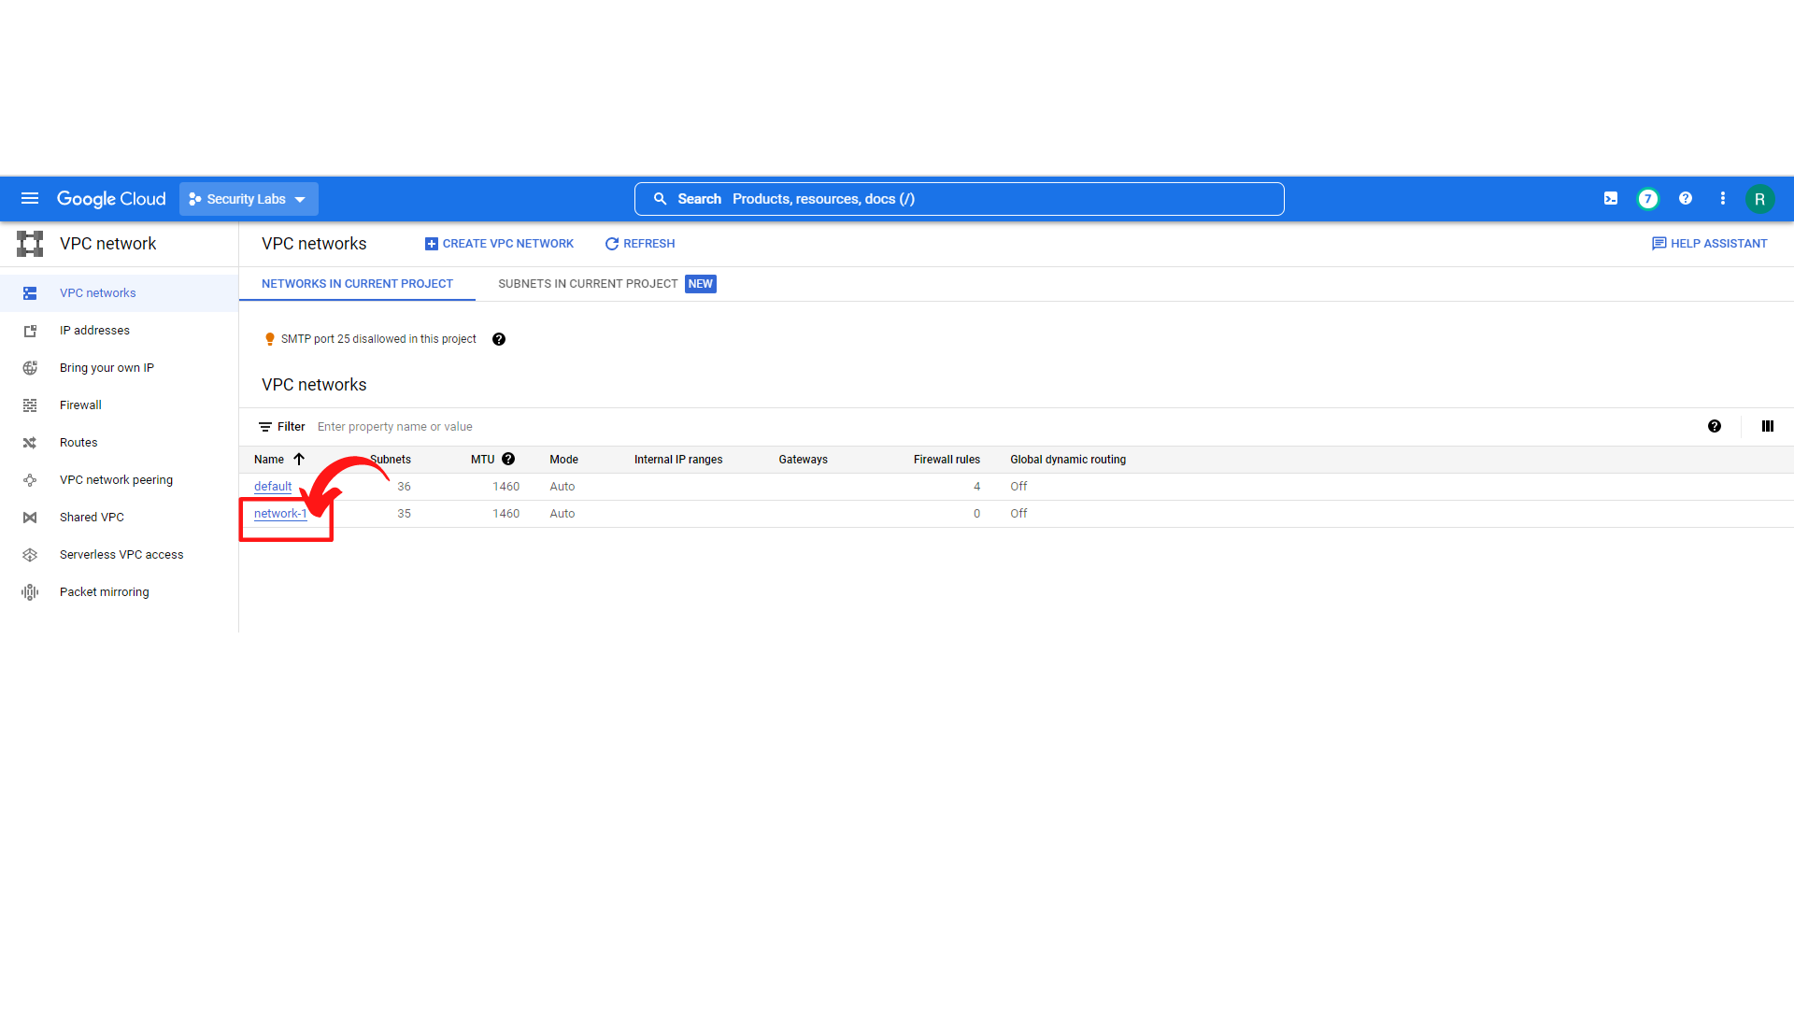

1. That’s it, you have successfully created an Auto Mode VPC Network.